A Guide to Talking with Your Pastor about InterVarsity

*Advocating for InterVarsity*



**Prepare for the meeting**

Take a few minutes to

* Identify what you love about the church so far.
* Identify how InterVarsity helped you grow as a disciple and a leader. Is there a story that you could tell to illustrate this?
* Identify what you want to advocate for. [(See “Church Advocacy Steps”.)]
* Order a book that you can give the pastor as a gift. Here are four suggestions from IVP. (Use your 40% InterVarsity alumni discount.)



* + For a church eager to grow in evangelism: *Breaking the Huddle* by Don Everts, Doug Schaupp, and Val Gordon takes what we’ve learned in InterVarsity about helping huddled communities become conversion communities. 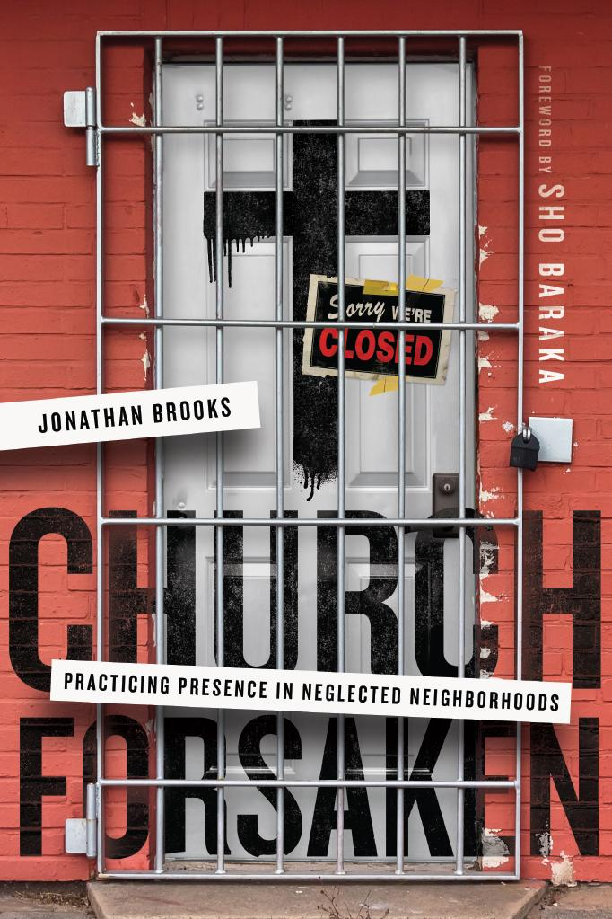
  + For a church eager to reach its distressed neighborhood: *Church Forsaken* by Jonathan Brooks looks at how a church in Chicago’s Englewood neighborhood is reaching out to and serving its community.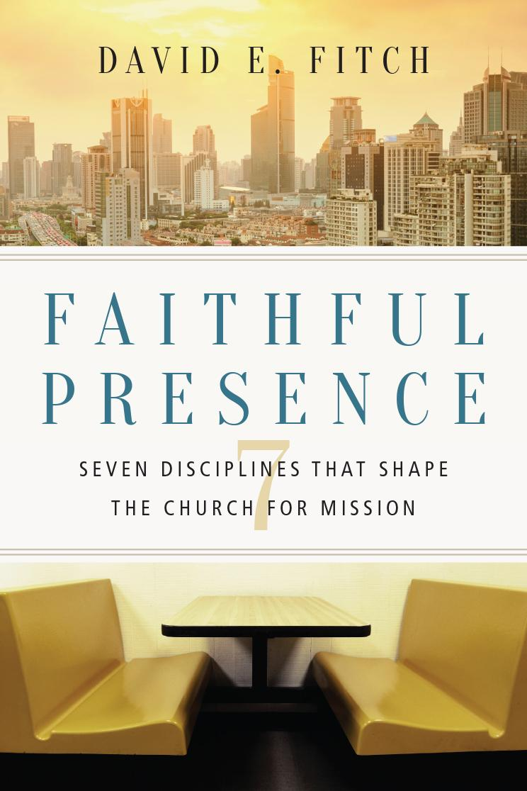
  + For a church eager to engage the culture: *Faithful Presence* by David Fitch identifies seven classic church practices that are startlingly relevant in today’s world.
  + When you just aren’t sure: *The Living Church* by John Stott. This book is a solid reminder of what the church is and why it exists. 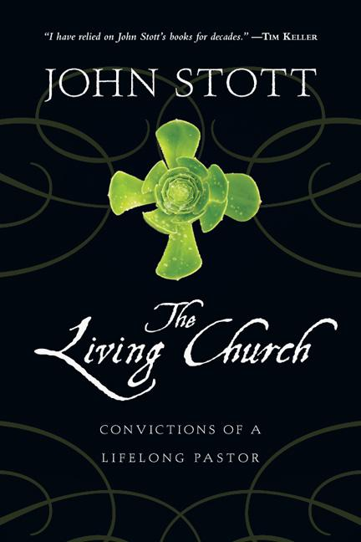

**At the meeting**

Follow this agenda

* Thank the pastor for their time.
* Share what you have appreciated about the church so far. Thank the pastor for their leadership.
* State your goal: “I would love to tell you a little about what I’ve learned as an InterVarsity student, but I also would love to hear your vision for the church [and where I could serve].”
* Ask the pastor about their vision and dreams for the church.
* Connect their vision and dream to your InterVarsity experience. (If you need to, explain what InterVarsity does. Remember NSO?)
* Share how InterVarsity depended your discipleship and grew your leadership skills. Ask how you might use those skills/experiences in the church now.
* Take a moment to advocate for InterVarsity (e.g., “I gained so much from my InterVarsity experience. It’s one of the reasons I want to serve well at this church. Would you be willing to give me an opportunity to connect the high school and college students at our church with InterVarsity?”
* Explore the options and nail down a plan.
* Give the gift to your pastor.

**After the meeting**

Take the following steps

* Within 24 hours, send an email to your pastor thanking them for their time and confirming the plan you discussed.
* Outline next steps on your advocacy plan.
* [Download this free gift from IVP] [link]